AWS API Gateway

1.Create API in AWS API Gateway
Objective
Create a new API using AWS API Gateway to expose backend services.
Step-by-Step Procedure
Step 1: Log in to the AWS Management Console.
Step 2: Navigate to API Gateway.
Step 3: Click Create API.
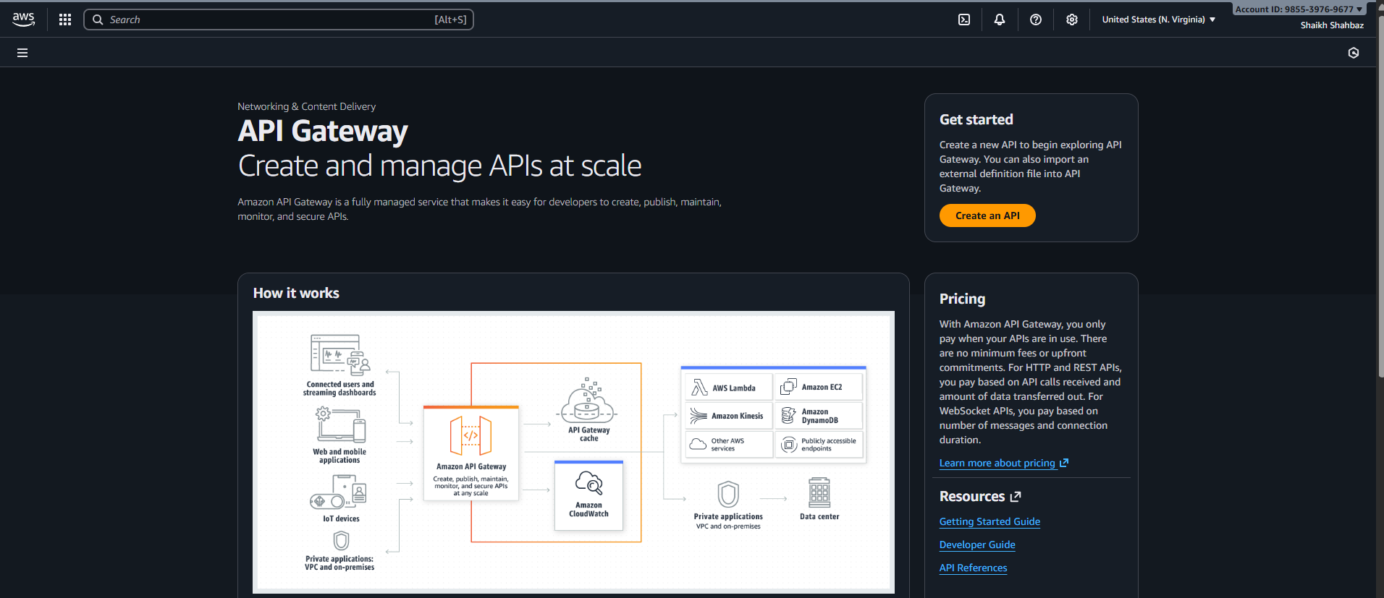
Step 4: Select REST API.
Step 5: Click Build.
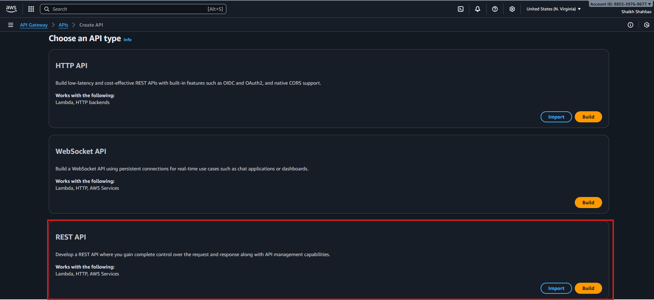
Step 6: Choose New API.
Step 7: Enter API name:
MyFirstAPI
Step 8: Select Endpoint Type: Regional.
Step 9: Click Create API.
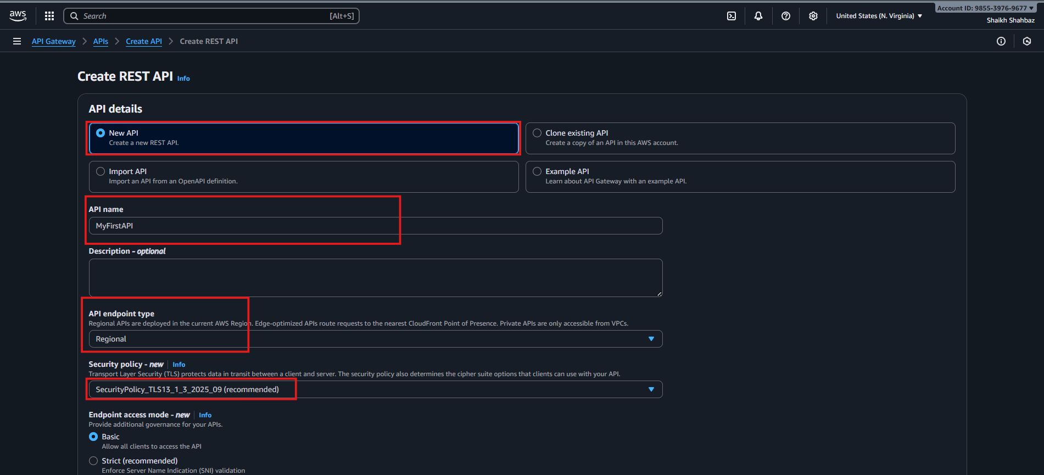
Validation:
API Gateway successfully created and is Available.
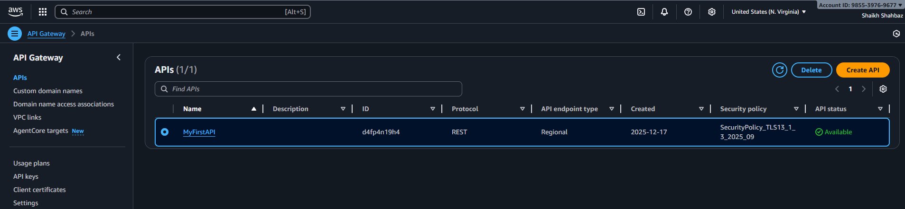
2.Create GET Method
Objective
Create a GET method to retrieve data from the API.
Step-by-Step Procedure
Step 1: Select your API (MyFirstAPI).
Step 2: Select Resources.
Step 3: Click Actions → Create Resource.
Step 4: Resource name:
items
Step 5: Resource path:
/
Step 6: Click Create Resource.

Step 7: Select /items.
Step 8: Click Actions → Create Method.
Step 9: Select GET from the dropdown.
Step 10: Click / enable lambda proxy integration.
Step 11: Integration type:
- Choose Mock Integration (for testing)
(or Lambda if backend exists)
Step 12: Click Save.
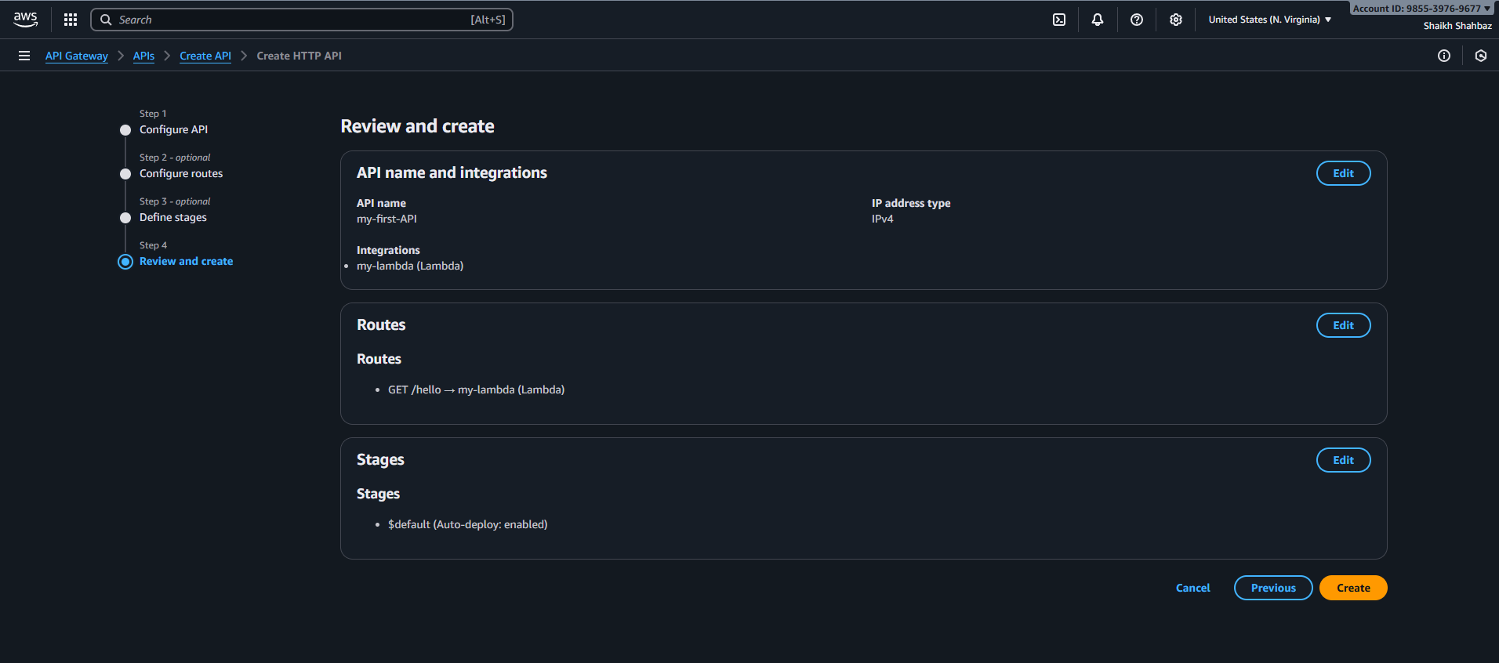
Validation:
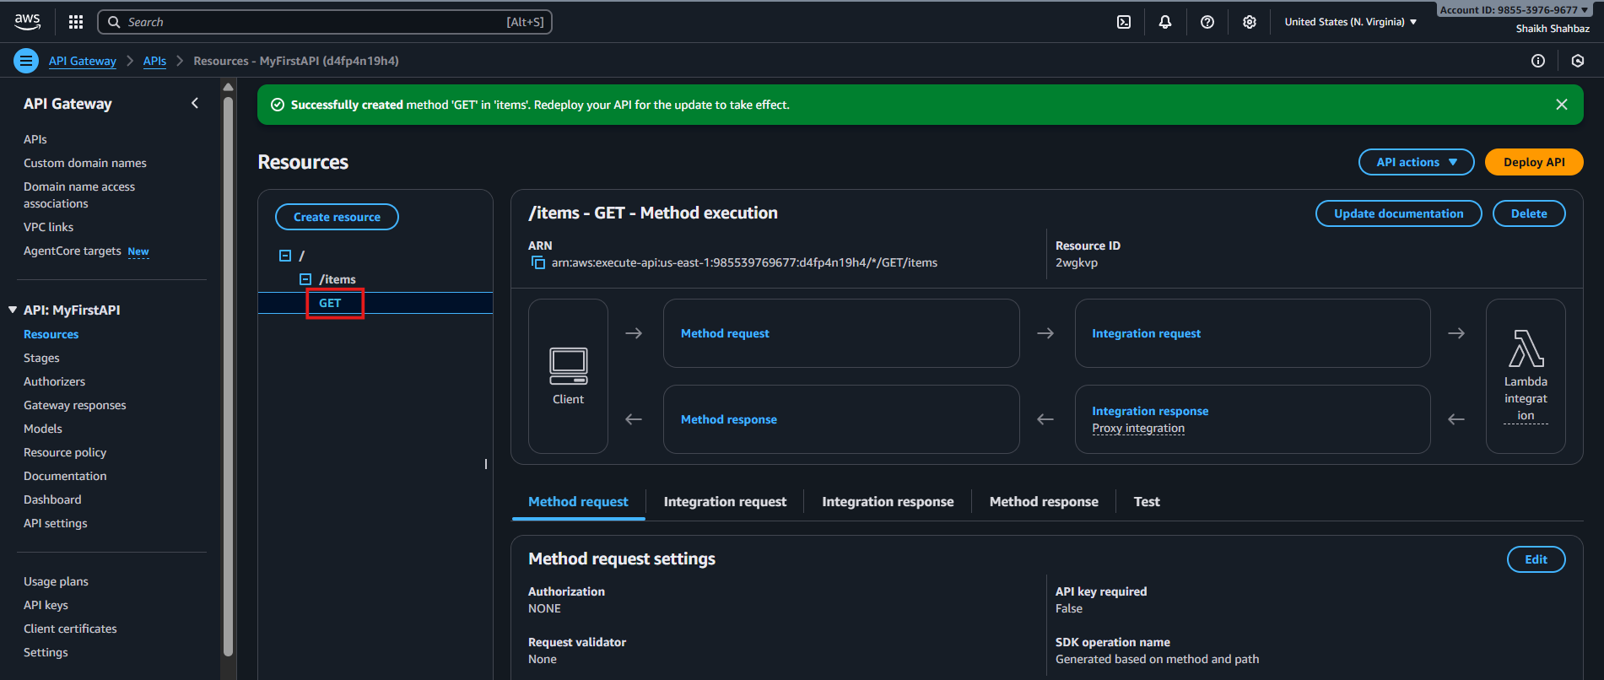

3.Create POST Method
Objective
Create a POST method to send data to the API.
Step-by-Step Procedure
Step 1: Select resource /items.
Step 2: Click Actions → Create Method.
Step 3: Select POST.
Step 4: Click the ✔️ icon.
Step 5: Integration type:
- Choose Mock Integration (or Lambda integration)
Step 6: Click Save.
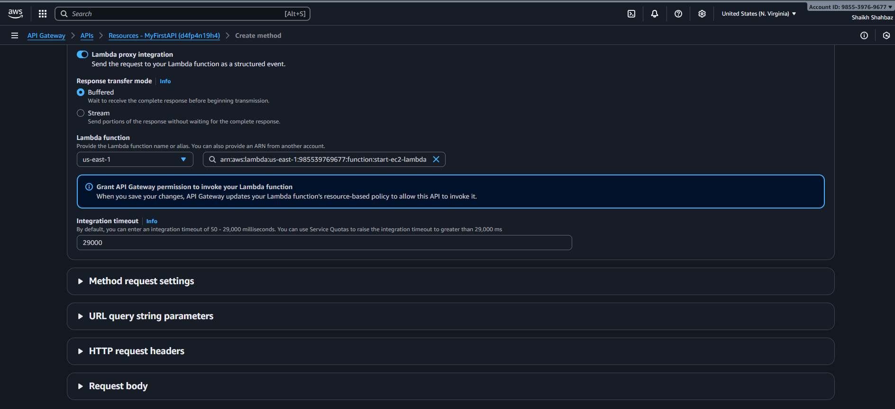
Validation:
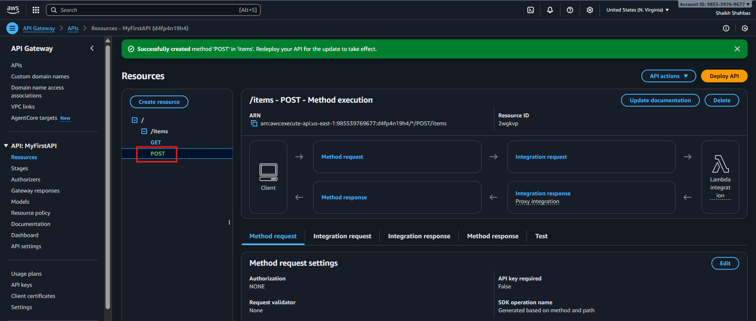
4.Deploy API
Objective
Make the API publicly accessible.
Step-by-Step Procedure
Step 1: Click Actions → Deploy API.
Step 2: Deployment stage:
- Select New Stage
Step 3: Stage name: shahbaz
Step 4: Click Deploy.
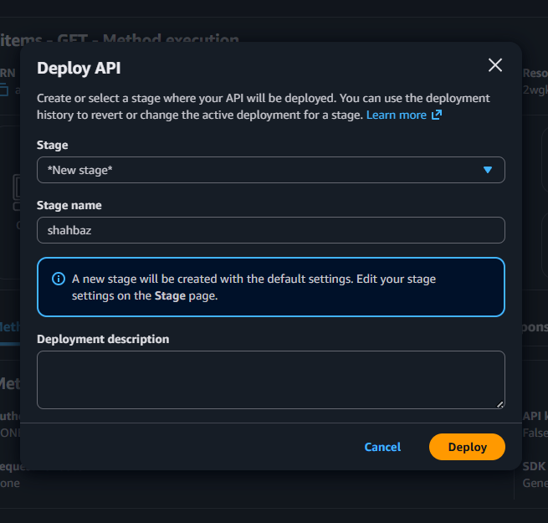
A Invoke URL will be generated.
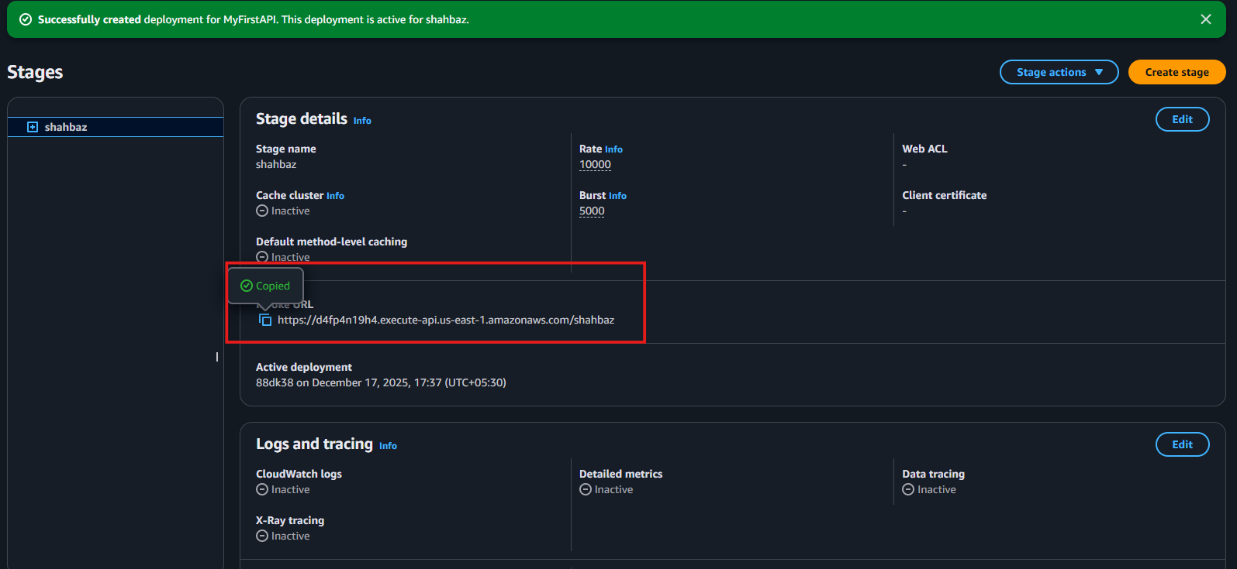
5.Test API
Objective
Verify that GET and POST methods work correctly.
🔹 Test GET Methode
Step 1: Open browser / Postman.
Step 2: Enter:
<Invoke-URL>/items
Step 3: Press Enter and verify response.
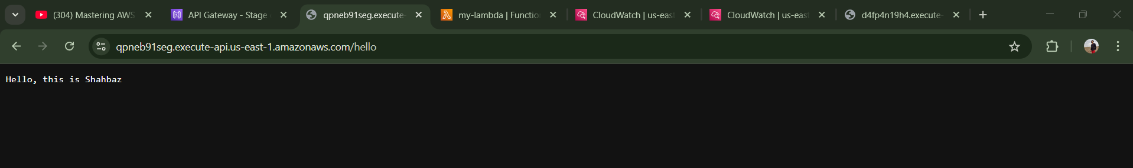
Validation:


